# INTRODUCTION

1.1Overview

Population growth is the increase in the number of humans on Earth. For most of human history our population size was relatively stable. But with [**innovation**](https://ugc.berkeley.edu/background-content/innovation/) and industrialization, energy, [**food**](https://ugc.berkeley.edu/background-content/food-availability-and-nutrition/), [**water**](https://ugc.berkeley.edu/background-content/freshwater-quality-and-availability/), and [**medical care**](https://ugc.berkeley.edu/background-content/health-disease/) became more available and reliable. Consequently, global human population rapidly increased, and continues to do so, with dramatic impacts on global climate and ecosystems. We will need technological and social innovation to help us support the world’s population as we adapt to and mitigate climate and environmental changes.

* Increasing the [**extraction of resources**](https://ugc.berkeley.edu/background-content/resource-extraction/) from the environment. These resources include [**fossil fuels**](https://ugc.berkeley.edu/background-content/burning-of-fossil-fuels/) (oil, gas, and coal), minerals, [**trees**](https://ugc.berkeley.edu/background-content/deforestation-reforestation/), **water**, and [**wildlife**](https://ugc.berkeley.edu/background-content/fishing-hunting/), especially in the oceans. The process of removing resources, in turn, often releases [**pollutants and waste**](https://ugc.berkeley.edu/background-content/pollutants-and-waste/) that reduce [**air**](https://ugc.berkeley.edu/background-content/air-quality/) and **water quality**, and harm the **health**of humans and other species.
* Increasing the **burning of** **fossil fuels** for energy to generate electricity, and to power transportation (for example, cars and planes) and industrial processes.
* Increase in **freshwater use** for drinking, [**agriculture**](https://ugc.berkeley.edu/background-content/agricultural-activities/), recreation, and industrial processes. Freshwater is **extracted**from lakes, rivers, the ground, and man-made reservoirs.
* Increasing ecological impacts on environments. **Forests** and other [**habitats**](https://ugc.berkeley.edu/background-content/habitat-loss-restoration/) are disturbed or destroyed to construct [**urban areas**](https://ugc.berkeley.edu/background-content/urbanization/) including the construction of homes, businesses, and roads to accommodate growing populations. Additionally, as populations increase, more land is used for **agricultural activities** to grow crops and support livestock. This, in turn, can decrease [**species populations**](https://ugc.berkeley.edu/background-content/species-populations/)**,**geographic[**ranges**](https://ugc.berkeley.edu/background-content/species-ranges/)**,**[**biodiversity**](https://ugc.berkeley.edu/background-content/biodiversity/)**,** and alter [**interactions**](https://ugc.berkeley.edu/background-content/species-interactions/) among organisms.
* **Increasing fishing and hunting**, which reduces **species populations**of the exploited species. Fishing and hunting can also indirectly increase numbers of species that are not fished or hunted if more resources become available for the species that remain in the ecosystem.

1.2 Purpose

Population forecasting is a method to predict/forecast the future population of an area. Usually, the population at the design period of water supply systems is predicted to find the water demand at that time, as the systems are required to fulfill their purposes till the end of the design period.

2. Problem definition & design thinking

2.1 Empathy Map

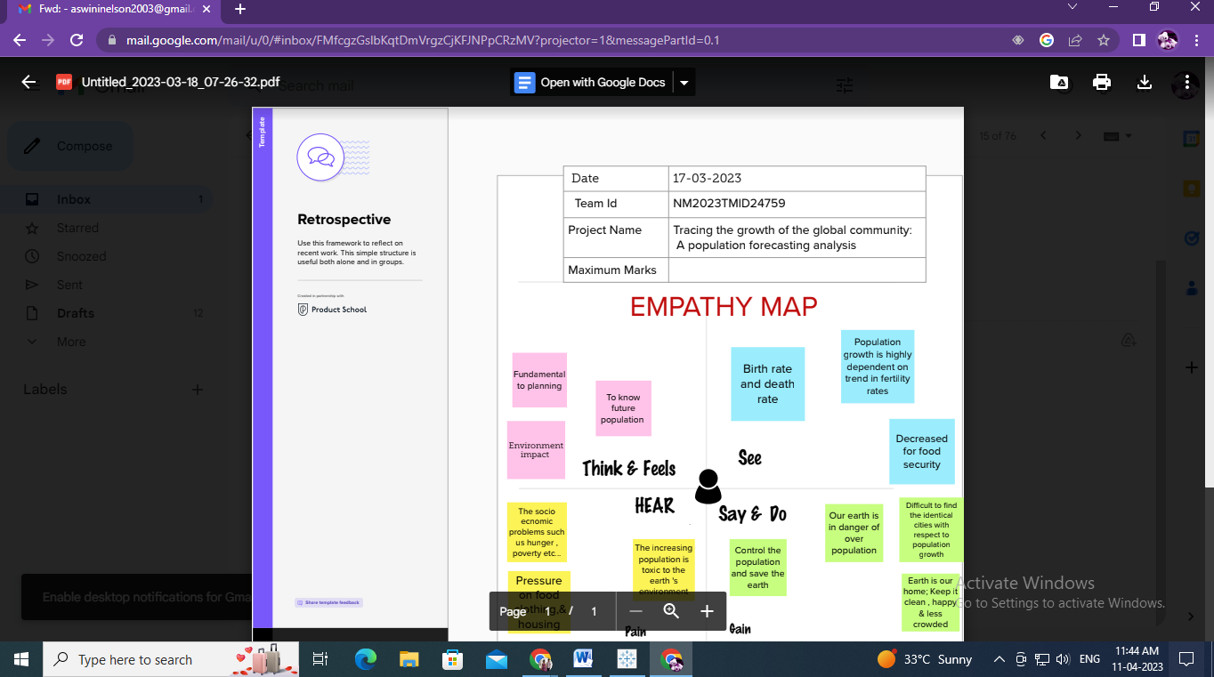

2.2. Ideation & brainstorming map

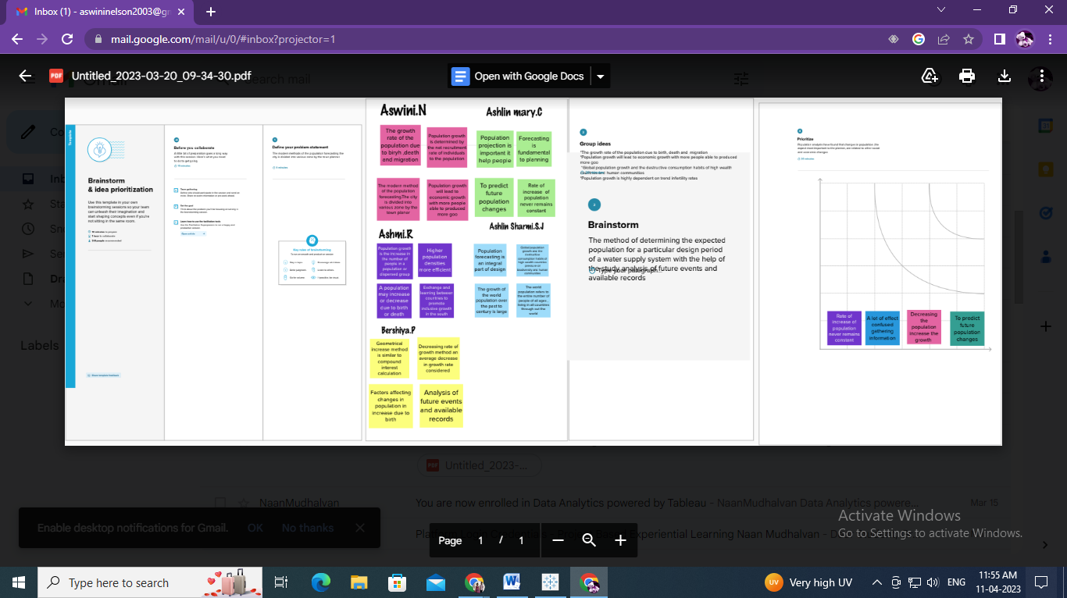

3. RESULT

DASHBOARD 1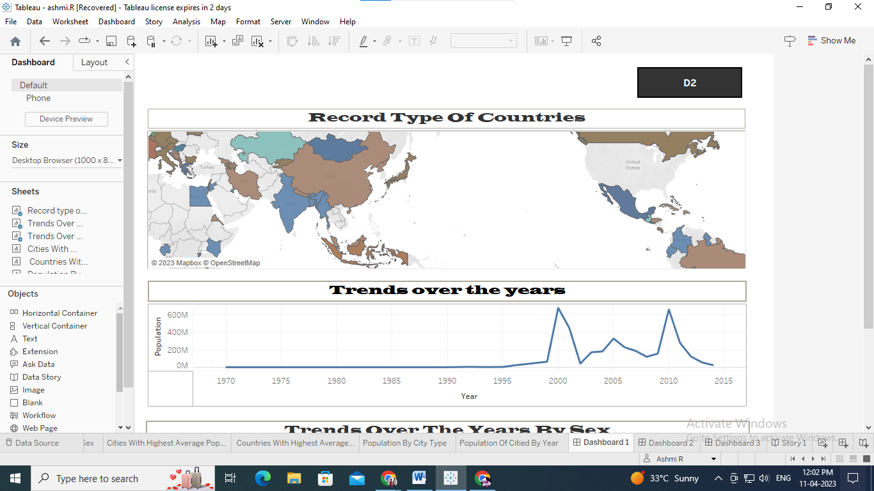

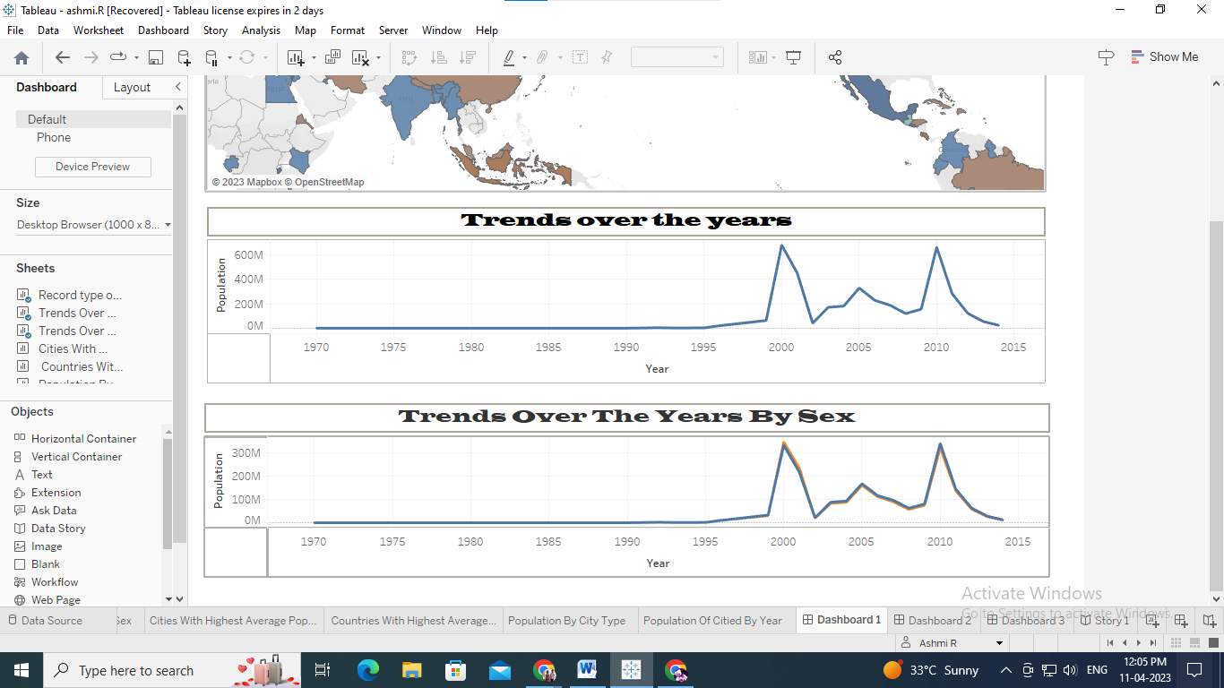

DASHBOARD 2

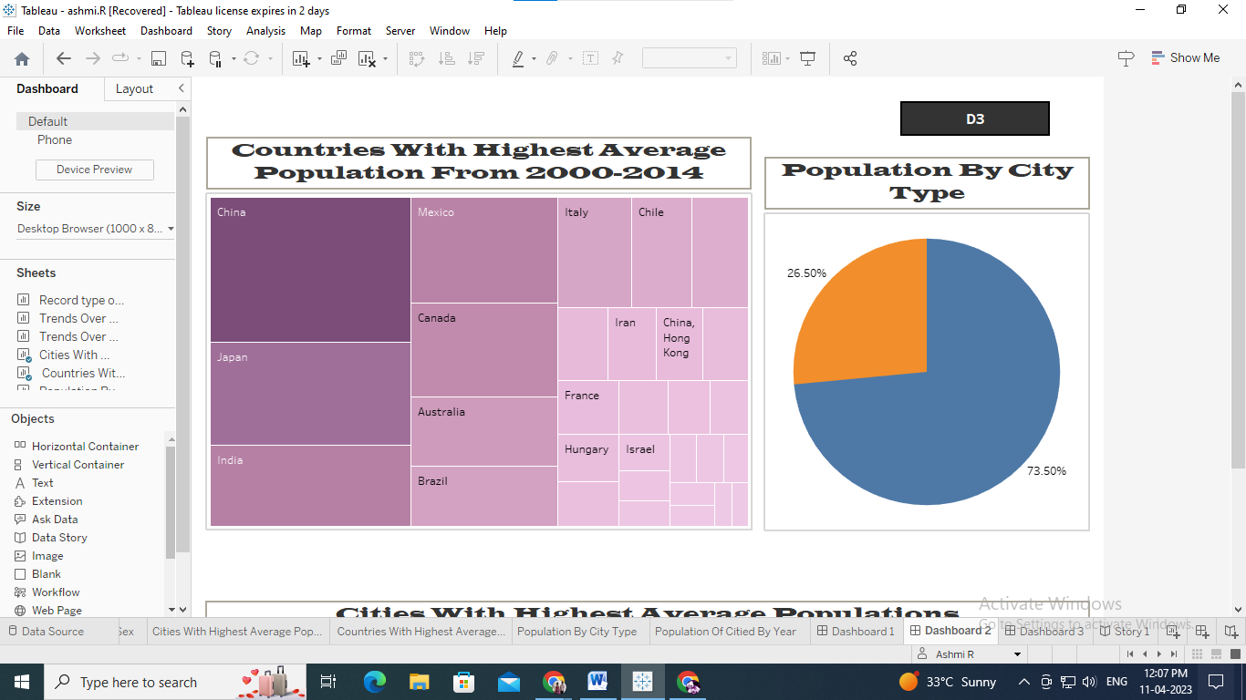

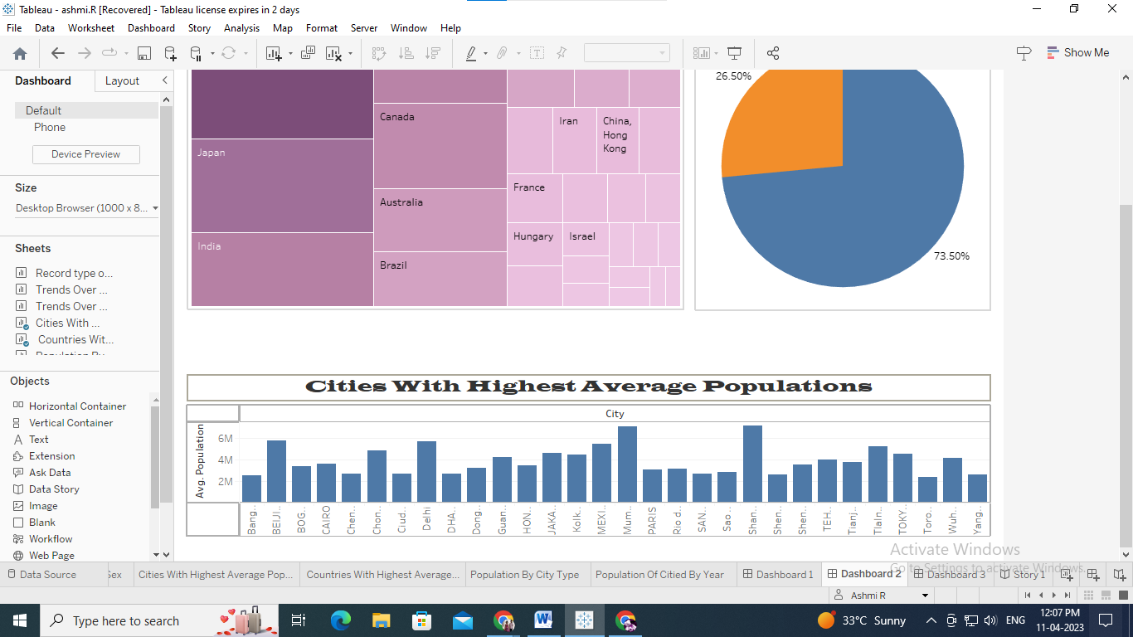

DASHBOARD 3

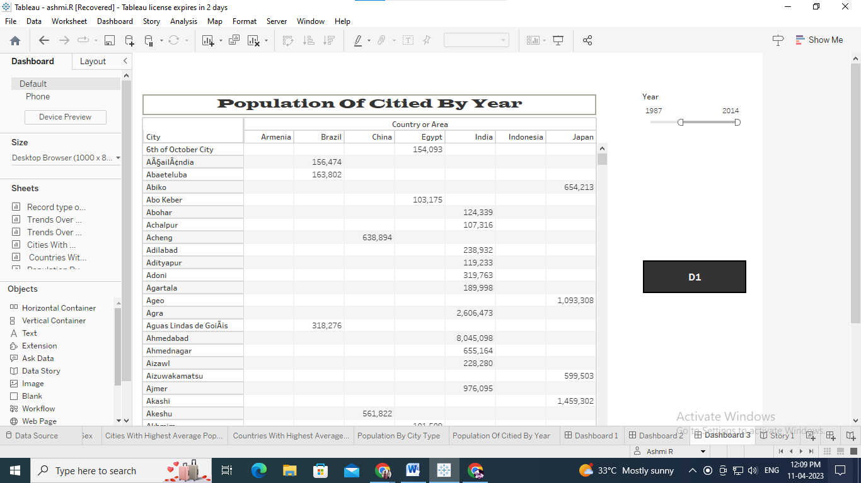

STORY

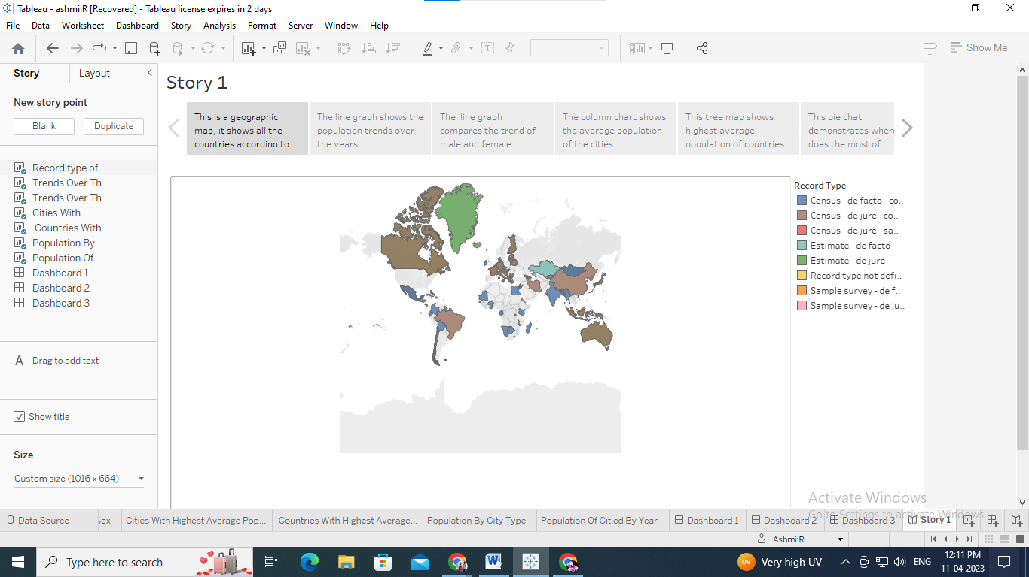

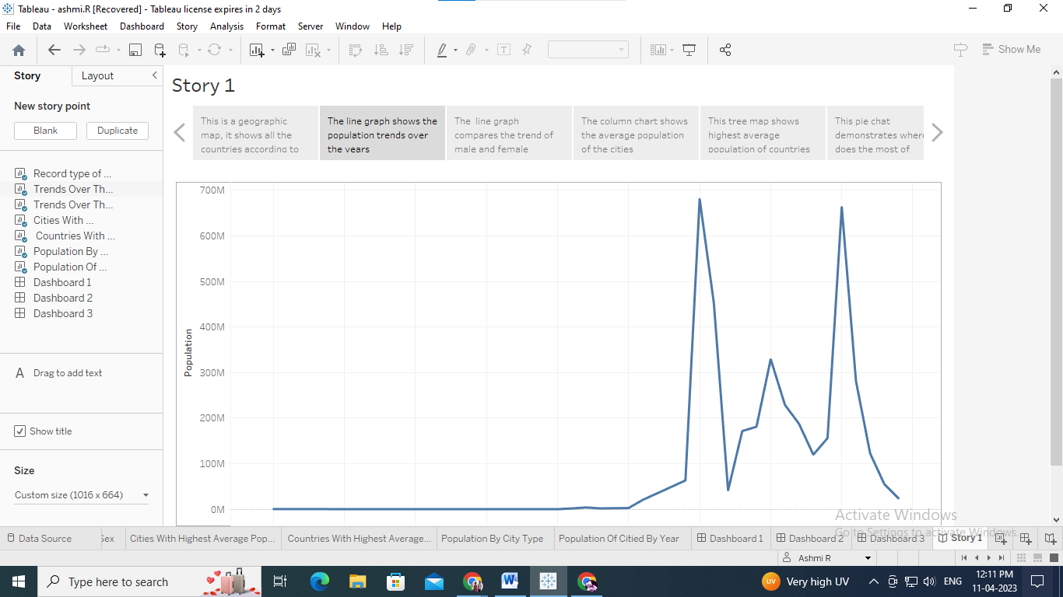

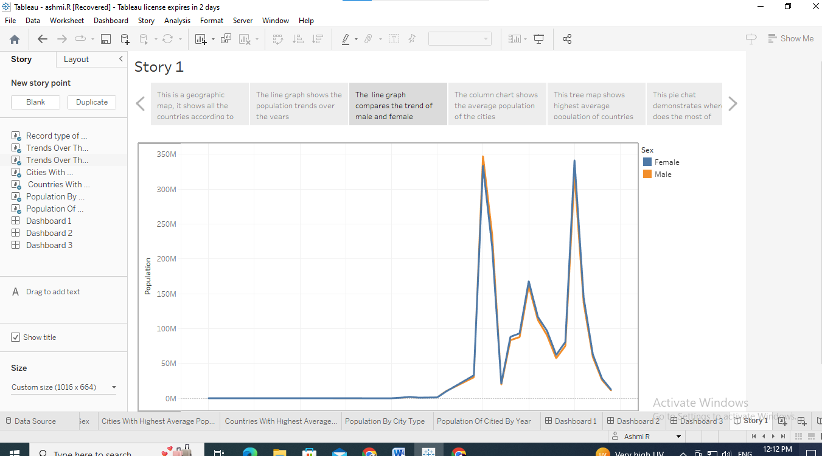

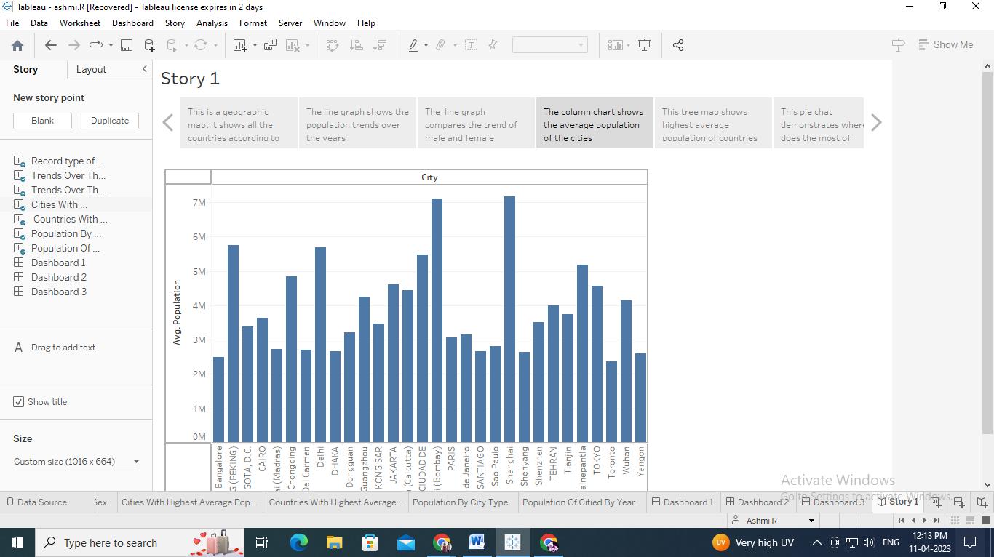

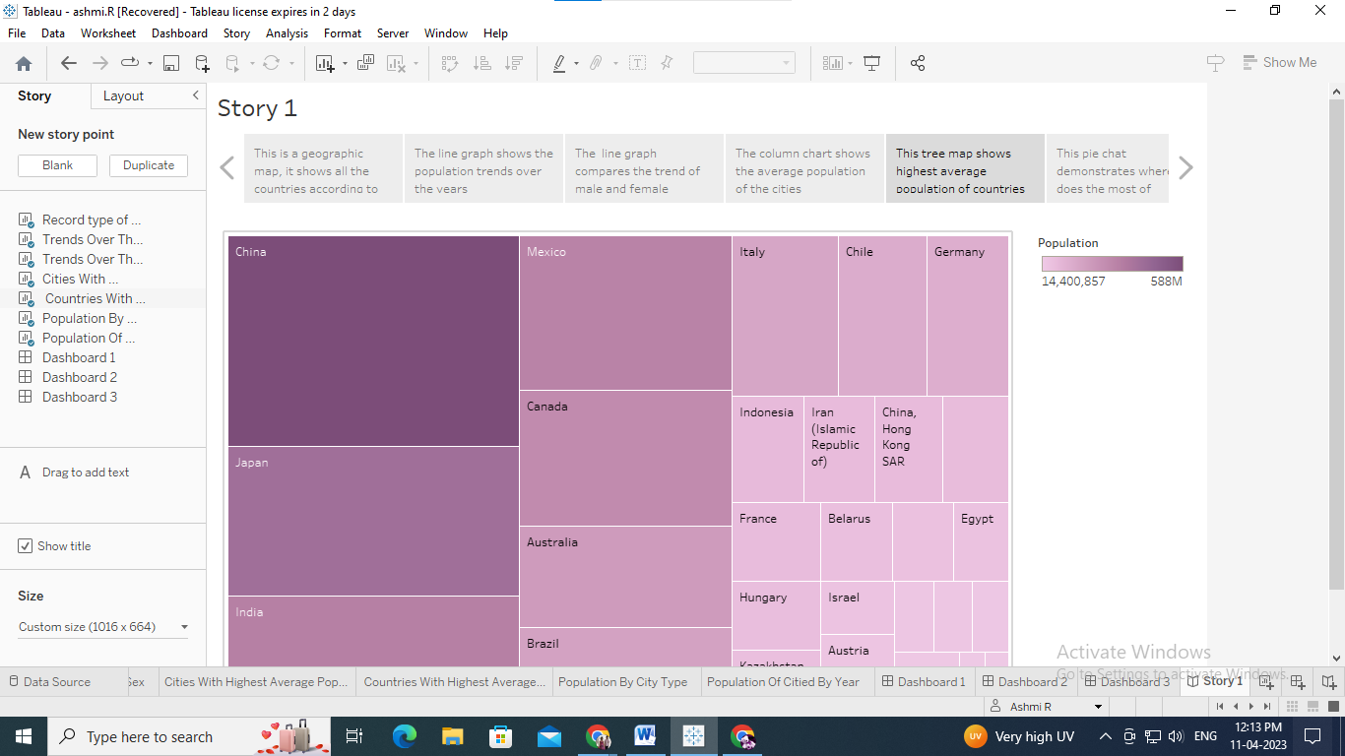

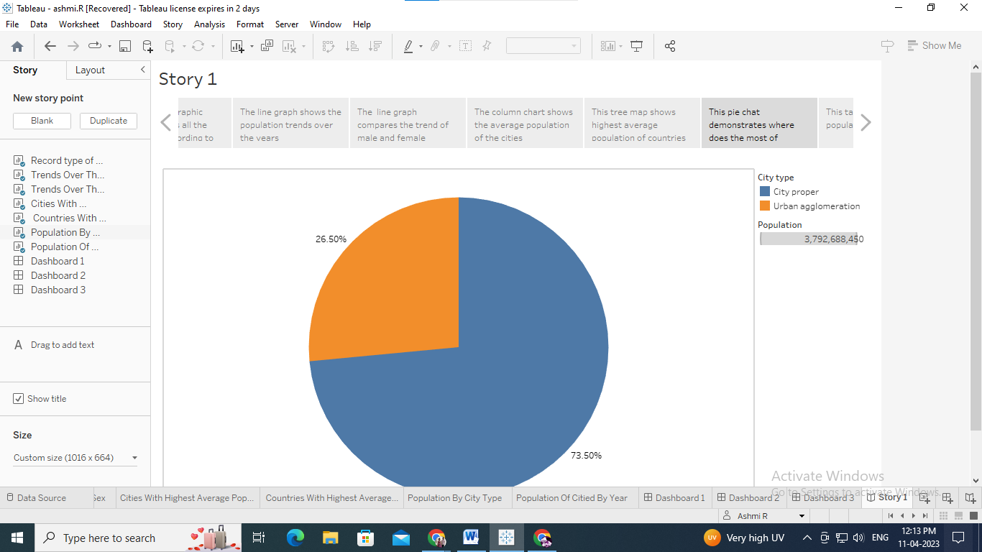

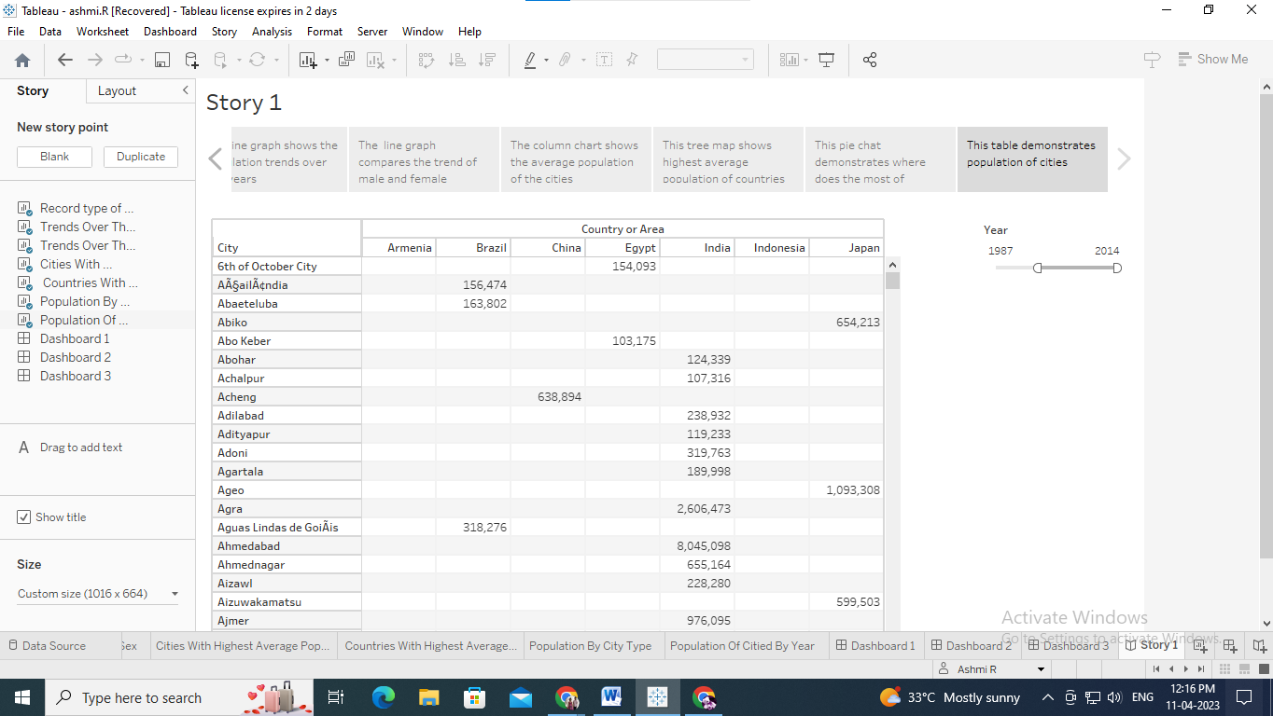

ADVANTAGES & DISADVANTAGES

ADVANTAGES

* **Restrictions on improvements in living standards.**
* More people leads to greater human capital.
* Higher economic growth.
* Economies of scale.
* The efficiency of higher population density.
* The improved demographic structure of society.
* Critical mass.

DISADVANTAGES

* As the population increases there will be more chances for the exploitation of natural resources.
* Low Per Capita Income.
* Low Quality of Life.
* Environmental Degradation and Others.
* The number of unproductive consumers is increasing.
* Unemployment / increased dependency.

5.APPLICATIONS

Population growth will lead to **economic growth with more people able to produce more goods**. It will lead to higher tax revenues which can be spent on public goods, such as health care and environmental project

6. CONCLUSION

The Earth's current population is almost 7.6 billion people, and it is expanding. It is expected to surpass 8 billion people by 2025, 9 billion by 2040, and 11 billion by 2100. The population is quickly increasing, far surpassing our planet's ability to maintain it, given existing habits.

7. FUTURE SCOPE

Towards the end of the century, the UN expects the global population to reach its peak at around 10.4 billion. After this point, the UN demographers project global population growth to become negative, so that the world population starts to fall slowly. It is hard to know the population dynamics beyond 2100. **A quantitative study of human distribution in a particular area or space**. Variation in population density due to environmental or geographical condition. The demographic phenomenon like mortality, growth rate, birth rate, etc. is studied.

8. APPENDIX

* 1. Source Code :

D:/population%20forecasting%20analysis/Project%20Files/Web%20application%20files/HTML%20Template%20files/ashmi.html